Sorenson Industries Modular Mechanized Soldier represents the latest advancement in mechanized warfare. The brainchild of Sorenson Industries CEO Hawke Sorenson, the SIMMS seeks to modernize mechanized warfare and reduce capital cost by creating the world’s first truly multi-role fighting machine.
In the past, mechanized units required time-consuming and costly refits to operate within different tactical theaters, causing navies to maintain a large costly fleet of battle ready combat frames for different use. With the modular mechanized unit, a single carrier can service multiple theaters of operation, from pirate bases hidden in the rings of Saturn, to dissident settlers on the desert moons of Epsilon Eridani β.
The SIMMS is able to accomplish this by assembling a mechanized unit on-the-go to exact specifications to fit any mission profile, including weapon load-out, power needs, mobility needs, sensor packages, and much more. This is accomplished via the astounding R-237 assembly computer and assembler arms. Replacing a traditional hanger and flight deck, the R-237 can assemble and sortie a mechanized unit in under 45 seconds.

Additionally a single R-237 can control up to four separate sortie and launch processes. With input from flight control, the R-237 can safely and efficiently launch up to 6 SIMMs a minute, far exceeding current readiness directives.
But what of the mechanized unit itself? Users will have the option of several preset configurations, as well as on-the-fly customization abilities. High-endurance recon msission? Take along a power generator, extra rations and stealth plating. Need to repel an attacking force while reinforcements arrive? Heavy weapons and a battery pack might be the way to go. The possibilities are limitless.

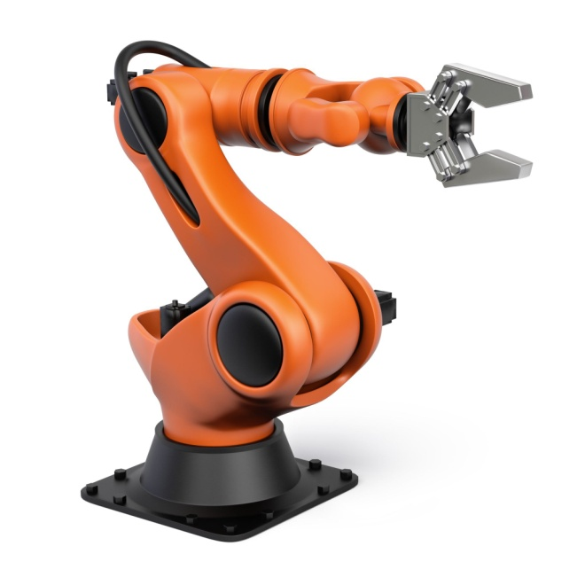
Armaments
Sorenson Industries Armory
Disruptor Whip
SH-1 Interdictor
L-101 Magnetic Rifle
L-201 Magnetic Rifle
L-301 “Tesla” Rifle
AIM-19 “Sparrow”
AIM-25 “Osprey”
AIM-57 “Falcon”
SOG Specialty Knives
SOG-3153 Bowie
SOG-3154 MS Sword
Springfield Armory
20 mm Autocannon
40 mm Autocannon
Raytheon
BGM-34M Bunker Buster

Technical Readout
Mechanized Soldier
Height: 10 m
Average Weight: 1800 kg
Power options
1000 kWh Battery
3000 kWh battery
30 MW H₃ Fusion Reactor
Top Speed:
1,300 km/h (fighter configuration)
Targeting Computer:
Sorenson Industry Targeting Computer
Raytheon X27 Fire Control System (optional)
Armor:
8mm fairing plating
20 mm Steel/Kevlar reinforced plating
40 mm Carbon Nanotube plating
40 mm Advanced Ceramics plating
Deflector System:
SI Armory 1-4 KW Deflector

Sorenson Industries
Modular Mechanized Soldier

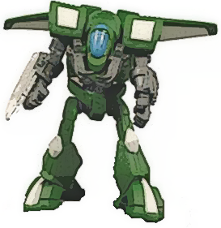

MS-24 “Alexander”

